FIXING FINISHED GOODS AND INVOICED COSTS

Step 1 Backup Database to Local C Disk Drive (Hence have users Log out.)
Step 2 Make sure cost on PO or Job is accurate.
Step 3 Run N-Y-12 to transfer costs from PO to History File
Step 4 N-Y-12 This updates the cost from the Job File or PO File to update FG History.
Step 5 From FG item file, click the View Folder, Click the Recalc Costs
Enter * for all items. This will only run when N-K-1 Security is Yes. Security Password is required.
Step 6 N-Q-12 to update the invoice cost.

Cost on commission reports and/or the cost on a posted or unposted invoice may be updated via a sequence of utilities. If the cost is zero or wrong or ? shows then the cost must be fixed. This will require either correcting the estimate for manufacture items or updating the purchase order for purchased finished goods. Once an estimates cost is corrected, this cost must be transferred to the job file.

Estimated Costs can be transferred from estimate to Job File via the following:

- Estimates Job Stnds Button on the any of the folders.
- Job Stnds Button on the Job File.
- Recalc Job Cost on the Job File.

N-Q-12
The utility will move the cost for the finished goods from the purchase order for farm out and purchased finished goods as well as the cost from the job file for manufactured finished goods. The cost is moved to the bin/tag file for each receipt receipts transaction. The finished goods history cost is updated which in turn updates the bin/tag file.

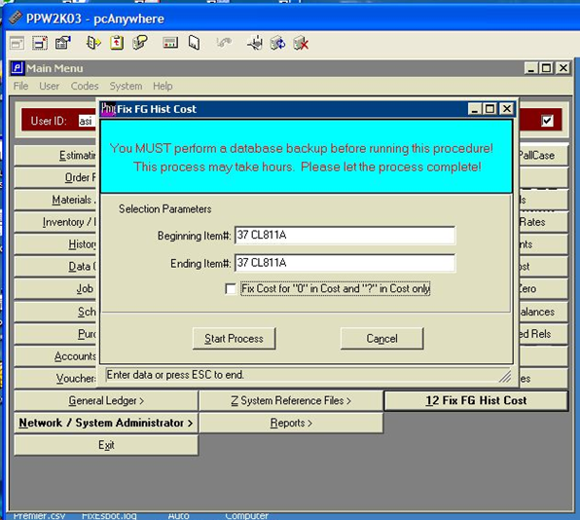

N-Q-12 Fix Invoice Cost

The utility will move the cost from the finished goods bin/tag file for that items receipt cost to the items line item cost on the invoice. The bill of lading trachks the exact bin and load tag number that is shipped, hence invoices. This utility will match the finished goods receipt to the bin and tag number on the invoice. You can run this for a specific invoice or range of invoices.

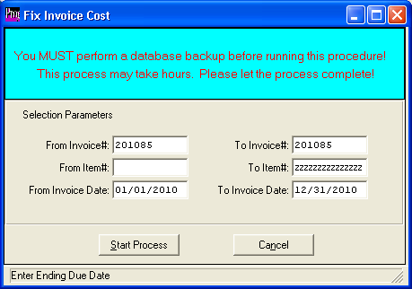Recalculation the
Finished Goods Items Cost and Quantity after Fixing Costs
This program will update the View Folder which is grand total or summary of costs.

